A000-Asia-China-Jiangsu Province-Cong-Square-Jade-Liangzhu culture-2500 BCE

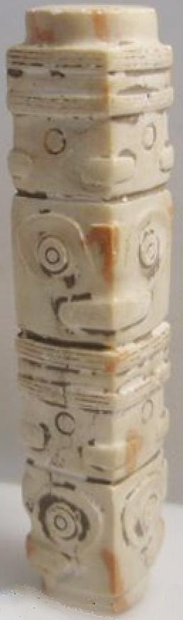

Case no.: 5

Accession Number:

Formal Label: China-Jiangsu Province-Cong-Square-Jade-Liangzhu culture-2500 BCE

**Display Description:**

The Neolithic Liangzhu culture was centered in the Jiangsu Province of China during the third millennium BCE. The Liangzhu jades were highly sophisticated. For instance, this jade cong has four different masks. Two depict perhaps deceased ancestors above their animal guardian or spirit below. While it is diminutive in size these features emulate features of larger cong. This cong is apparently devoted to two personages.

**LC Classification:** NK5750.2.A1

Date or Time Horizon: 2500 BCE

Geographical Area: Jiangsu Province

**Map:**

**GPS coordinates:**

Cultural Affiliation:

Media:

Dimensions: 1.4 cm., 1.4 cm., 7.8 cm.

Weight:

Condition:

Provenance:

**Discussion:**

**References:**